EXTERNAL ASSOCIATE
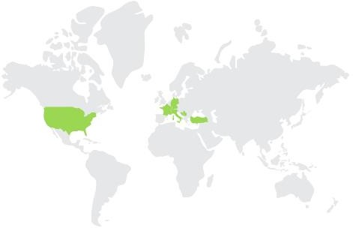 | SERBIA

 | NAME AND SURNAME: | Vladimir Mladenović
 | AFFILIATION: | Full Professor at University of Kragujevac Faculty of Technical Sciences Čačak
 | AREA OF EXPERTISE: | 5G EDGE computing, wireless communication, IoT, Artificial intelligence, machine learning, neural networks, deep learning, Image processing and computer vision, Symbolic computation and processing, and Fast algorithms.
 | RESEARCHER ID: (ORCID) | 0000-0001-8530-2312

SHORT BIOGRAPHY
Prof. Dr. Vladimir Mladenovic was born in 1975. He finished primary and secondary school in Paračin. He finished the Faculty of Electronic Engineering, University of Niš, in 2000. He acquired the title of Master of Science degree at the same university in 2005, and a doctor of technical sciences earned from the Technical Faculty in Čačak, the University of Kragujevac in 2009.

Vladimir Mladenovic worked in the Serbian glass factory in Paračin as an IT manager since 2001. to 2004, as well as a teacher of courses in the field of electrical engineering since 2004. to 2009. As a professor of professional studies in the department of electrical engineering, he worked since 2009. up to 2013.He is the author of more than 90 scientific papers published in conferences and journals of national and international importance. He is the owner and inventor of three patents of which one is in commercial use. He is a licensed engineer to transfer technologies by the World Intellectual Property Organization (World Intellectual Property Organization - WIPO) and the Intellectual Property Office of Serbia, a member of the IEEE, the Association of Engineers and Technicians of Serbia, and President of the Society for Innovation and technical-technological development Paračin.

The main areas of research are 5G EDGE computing, wireless communication, IoT, Artificial intelligence, machine learning, neural networks, deep learning, Image processing and computer vision, Symbolic computation and processing, and Fast algorithms.

